THE PEERLESS COLTS

T
he cricketing dominance of the Colts lasted thirty years. From 1885 to WWI. Here we discuss the how the club had fared from about 1886 to the closing of the nineteenth century.

Fin de siecle

Foenander in his book Sixty Years of Ceylon Cricket published in 1924 has statistics for matches against all opponents including minor opponents (mostly educational institutions, outstation clubs and Bloomfield). Between 1886 and 1900 the Colts played 170 games, against a total of 40 teams, winning 117 and losing 14 (Foenander 1924: 15-16, 1941: 90-91). In the same period the club only lost 7 matches, against the important teams. Six of the defeats occurred when the club was represented by their second XI.

RESULTS OF MATCHES PLAYED 1886 - 1900
Opponents | Played | Won | Lost | Drawn
Lord Hawke’s XI | 1 | 0 | 1 | 0
Picked European Teams | 9 | 6 | 1 | 2
Dimbulla-Dickoya | 2 | 1 | 1 | 0
D.M.C.C. | 4 | 3 | 0 | 1
Kandapola C. C. | 2 | 2 | 0 | 0
Nuwara Eliya C. C. | 3 | 3 | 0 | 0
A.B.C.D. (Kandy) | 5 | 3 | 1 | 1
Kelani Valley C. C. | 2 | 1 | 0 | 1
C.C.C | 9 | 5 | 1 | 3
Colombo Sports Club | 5 | 3 | 0 | 2
Garrison | 5 | 5 | 0 | 0
Gordon Highlanders | 1 | 1 | 0 | 0
Royal Warwicks | 2 | 2 | 0 | 0
NCC | 11 | 8 | 0 | 3
St. Patricks | 3 | 2 | 1 | 0
Matale S.C. | 5 | 5 | 0 | 0
Galle C. C. | 3 | 2 | 0 | 1
Matara C. C. | 3 | 3 | 0 | 0
Kalutara S.C. | 7 | 6 | 1 | 0
Combined Colleges | 3 | 0 | 1 | 2
Medical College C. C. | 1 | 1 | 0 | 0
Royal College | 10 | 5 | 2 | 3
Wesley College | 7 | 5 | 1 | 1
Technical College | 3 | 2 | 0 | 1
St. Joseph’s College | 2 | 1 | 0 | 1
Prince of Wales College | 2 | 2 | 0 | 0
Colombo Malay C. C. | 8 | 4 | 1 | 3
Bloomfield C & A C | 2 | 1 | 0 | 1
Railway C. C. | 6 | 2 | 1 | 3
Havelock C. C. | 1 | 1 | 0 | 0
Ceylon Volunteers | 2 | 1 | 0 | 1
Mr. F. May’s XI | 3 | 1 | 0 | 2
Opponents | Played | Won | Lost | Drawn
Melbridge C.C. | 1 | 1 | 0 | 0
Survey Department C.C. | 1 | 1 | 0 | 0
Convict Establishment C.C. | 1 | 0 | 0 | 1
Kotahena C.C. | 6 | 1 | 1 | 4
Cinnamon Gardens C.C. | 8 | 4 | 0 | 4
Fort C.C. | 4 | 4 | 0 | 0
Total | 157 | 102 | 14 | 41

S.S. Perera (1973) cites statistics from the 1901 publication Handbook to Ceylon by P.L. Bartholomuesz and lists the results of the important matches played by the Colts from 1886 to 1900.

Opponents | Played | Won | Lost | Drawn
Picked European Teams | 9 | 7 | 1 | 1
C.C.C | 9 | 5 | 1 | 3
D.M.C.C. | 5 | 4 | 0 | 1
Up Country | 1 | 1 | 0 | 0
Dimbulla-Dickoya | 2 | 1 | 1 | 0
Kandapola | 2 | 2 | 0 | 0
Nuwara Eliya | 3 | 3 | 0 | 0
Sports Club | 6 | 4 | 0 | 2
NCC | 12 | 9 | 0 | 3
Kandy S.C. | 4 | 4 | 0 | 0
Matale S.C. | 5 | 5 | 0 | 0
Kandy & Matale | 2 | 2 | O | 0
A.B.C.D. (Kandy) | 5 | 3 | 1 | 1
Garrison | 6 | 6 | 0 | 0
Regts. Team | 4 | 4 | 0 | 0
Lord Hawke’s Team | 1 | 0 | 1 | 0
Combined Colleges | 4 | 1 | 1 | 2
St. Patricks | 3 | 2 | 1 | 0
Total | 83 | 63 | 07 | 13
Highest Total – 345 for 5 wickets vs Sports Club in July 1900
Lowest Total – 24 vs Lord Hawke’s Team

Foenander in his book Sixty Years of Ceylon Cricket published in 1924 has statistics for matches against minor opponents. Eighty-Six games were played out of which 52 were won, 7 were lost and 23 drawn. The total arrived at by adding the two sets of figures are slightly less than the total given in the Handbook of cricket (1901) cited by S.S. Perera.

Team | Played | Won | Lost | Drawn
Important matches | 83 | 63 | 7 | 13
Other matches | 86 | 52 | 7 | 23
Total | 169 | 115 | 14 | 36
Overall total | 170 | 117 | 14 | 39

It should be noted that Foenander comes up with a figure of 157 matches played between 1888 and 1900 (1924). This is 12 to 13 games less than the total cited by the handbook, which itself is based on figures provided by Foenander. However, by breaking the statistics into two tiers, one gets an idea as to the strength of teams.

Feeder club

Interestingly, Bloomfield was a second-tier club in the nineteenth century and a feeder club to the Colts (Foenander 1924: 42 – 43). The Bloomfield team that beat Melridge in 1894 to survive as a club consisted of many Colts cricketers of previous years. It included Charles Heyn, W. de Fransz, Dr. S.P. Joseph, N.A. Paternott, W. de Rozayro and A.C. Van Cuylenberg. C. Heyn coached the club and W. de Fransz was a member. The best example of a Bloomfield player moving to the Colts was Alfred Holsinger, a successful fast bowler who finished his career in England. Other famous Bloomfield men who joined the Colts in the nineties were – A.T. Pollocks, W. de Rozayro, D. Joseph, E.A. Joseph and Norman Paternott.

Until 1923 the Colts and Bloomfield played each other thrice, two of the encounters taking place in 1923.

Best performances

S.S. Perera (1973) summarises the performances which stood out. The highest total against the Colts was made by the Sports club: 1897 in November 1897. Although dismissed for 41 in the first innings the Colts went on to win by 8 wickets.

Bowling

The best bowlers for the club were T. Kelaart and A. Raffel who were outstanding in 1893 and 1894, respectively. Five teams, all of them in the upper ranks, were dismissed for 20 or under in a single innings over the 14-year period.

T. Kelaart was responsible for the club’s best bowling performance., against Nuwara Eliya C.C. in 1893. He bowled 10 overs in each innings and captured 8 for 7 and 6 for 12. All 14 wickets were cleaned bowled. Kelaart’s figures for that year were 257 overs, 117 maidens, 355 runs, 100 wickets, 3.5 average. The following year A. Raffel had the following figures. 114 overs, 30 maidens, 164 runs, 58 wickets, 2.8 average. This would include the 14 for 87 he took against an English team led by Stoddart on its way to an ashes series in 1894-5.

S.S. Perera also cites the Handbook to Ceylon cricket of 1902, in drawing out the best batting and bowling performers for the club per year.

YEAR | BATTING |  | BOWLING
 | NAME | AVE. | NAME | AVE.
1886
1887
1888 | P. Thomasz |  | C. Heyn
1889 | Dr. Ohlmus | 28.2 | T. Kelaart
1890 | J. Kelaart |  | C. Heyn | 7.70
1891 | J. Kelaart | 25 | C. Heyn | 3.79
1892 | S.P. Joseph | 19.00 | A. Raffel | 4.2
1893 | E. Weinman | 23.16 | T. Kelaart | 3.5
1894 | A. Raffel | 24.25 | A. Raffel | 2.82
1895 | A. Raffel |  | A. Holsinger
1896 | F. Tousaint |  | T. Kelaart
1897 | S.P. Joseph | 16.8 | A. Holsinger | 4.7
1898 | J.C. McHeyzer | 31.4 | T. Kelaart | 7.15
1899 | J.C. McHeyzer | 28.99 | T. Kelaart | 5.90
1900 | C.E. Perera | 28.7 | T. Kelaart | 6.94

At the end of the era

THE 1900 TEAM
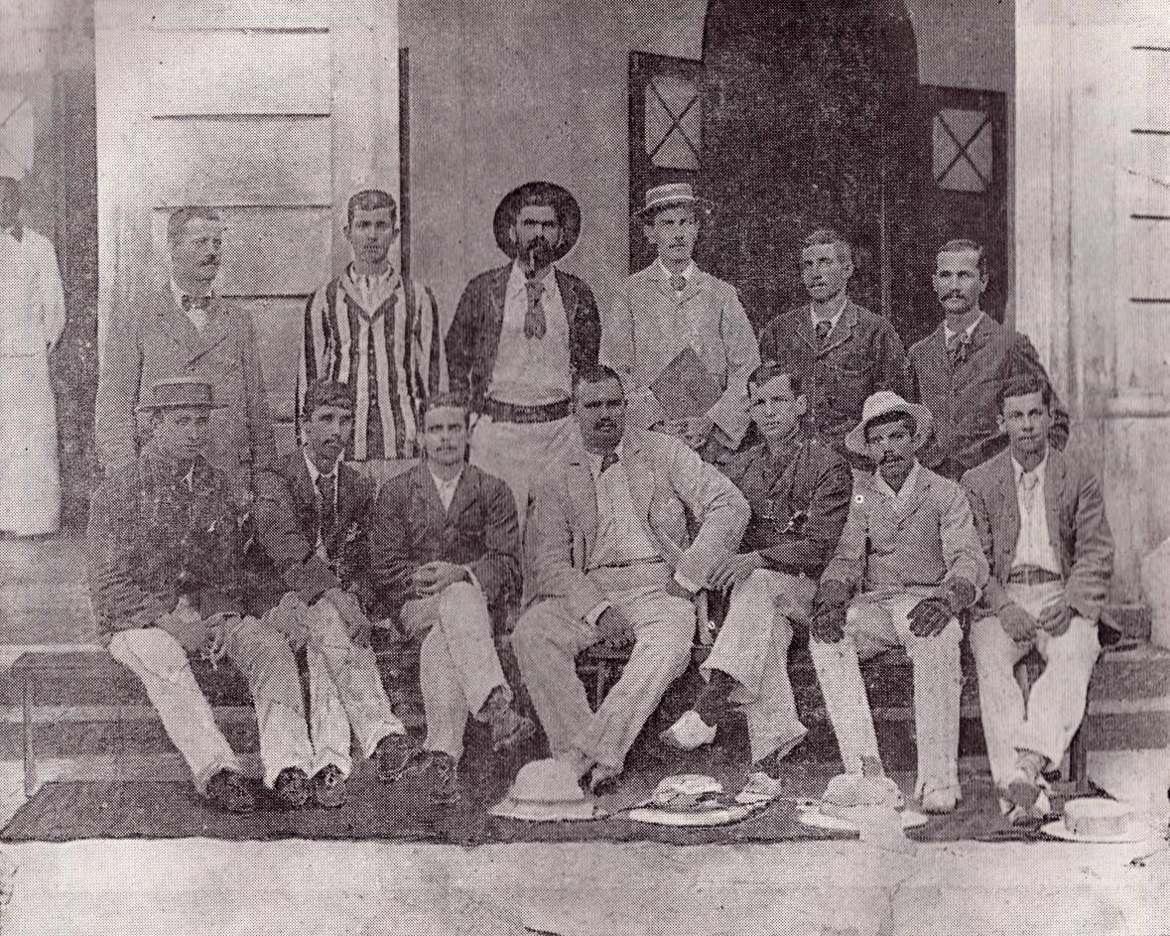
Seated (L to R): L.E. Thomasz, A.S. Peglotte, Tommy Kelaart, W. de Fransz, J.S. Scharenguivel,
W.D. Rozairo, ______
Standing (L to R): C.E. Perera, J.C. McHeyzer, _________, ________, J.’Banda’ Kelaart, S.P. Joseph

Courtesy of the Colts centenary souvenir

Banda and Tommy Kelaart are brothers. The other brother to play for the Colts was Colvin.

It is possible that L.E. Thomasz is related to Michael and Paddy Thomasz. He could be either Freddy or Bonny Thomasz. An interview with Michael Thomaz appears later in the book.

It is also probable that J.S. Scharenguivel refers Dr. J.A. Scharenguivel (b. 1877) who left for Scotland in the 1880s (Refer appendix I). C.E. Perera played for both the Colts and the S.S.C. and is arguably one of the finest right-handed batsman the country had produced as of 1940. But the person identified in the picture as C.E. Perera, in the centenary souvenir, doesn’t resemble him at all. The person standing second from left is more likely to be him. Whoever captioned the photos for the 100th anniversary souvenir wasn’t entirely accurate in putting names to people.

Foenander (1941: 13) describes C.E. Perera as follows -

“C.E. Perera, who had the honour of playing in the first eleven of the Colts when still a schoolboy, was a product of Wesley College, and generally admitted to be the finest right-hand batsman produced by Ceylon. He was captain of Wesley when he was included in the famous Colts XI that beat Capt. C. Ward Jackson’s XI on Galle Face in 1898. On that occasion he made a memorable debut, scoring 71 not out at a time when the Colts were in a tight corner. He played in several other tests for the Colts, and always batted well. One of his greatest displays was given in 1901 against the Boers XI, at the Victoria Park, when he scored 90 not out, in a total of 146. He scored 120 not out against Matale in 1901, and also hit up 106 not out and 115 against the Sports Club. Between 1898 and 1907, when he passed away before he was thirty years of age, C.E. Perera was one of the most consistent scorers for the Colts. He enhanced his reputation when he went with the first Ceylonese team, mainly composed of members of the Colts, to Bombay. His brilliant batting and fielding thrilled the Indian crowds. Batting in very elegant style, C.E. Perera had a wide range of strokes all-round the wicket and was always an attractive attacking batsman. He also excelled as a fieldsman and was a useful change bowler”.

As far as Foenander is concerned, C.E. Perera is a Colt through and through. He deliberately avoids mentioning that he was due to captain the S.S.C. when he died.

It could very well be J.A. Scharenguivel. According to Foenander (1941: 12) Dr. J.A. Scharenguivel as a member of the St. Thomas’ XI, he was chosen to play for the Colts against the D.M.C.C. on Galle Face. Having won his spurs in that match he was honoured with a place in the Colts XI against Capt. C. Ward Jackson’s European XI played at Galle Face. He indulged in some hectic hitting in the second innings. He captained the combined colleges team which played against the Colts in 1898. He subsequently played for the Colts. Hence, he is likely to have left for Scotland after 1900.

